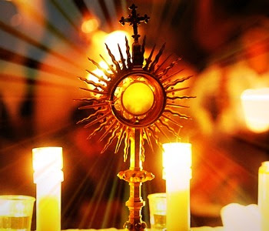
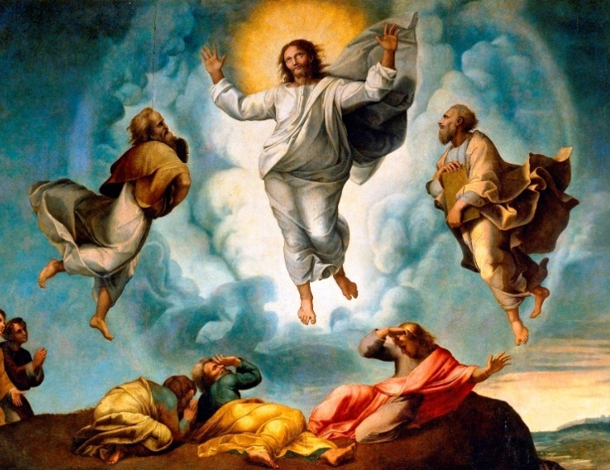
Calabrian Family in prayer
WORLD EUCHARISTIC ADORATION
Saturday 27 February 2021
«Master,
it is good for us to be here!»

Lent:
a time for renewing Faith, Hope and Love.

Message of the Holy Father Francis
for Lent 2021

- Exposition hymn

INTRODUCTION

In our Lenten journey towards Easter, let us remember the One who “humbled himself and became obedient unto death, even death on a cross” (Phil 2:8). During this season of conversion, let us renew our faith, draw from the “living water” of hope, and receive with open hearts the love of God, who makes us brothers and sisters in Christ.

With these words of Pope Francis in his message for Lent 2021¹, we introduce this holy hour of prayer and Eucharistic adoration. As a Calabrian Family we stand before Jesus, the absolute Master of this Opera, and with joyful faith we proclaim: "Master, it is nice for us to be here!"

It is nice to be in communion with the whole Calabrian Family, and to know that you have called us, Jesus, to climb Mount Tabor together to meet you alive, present in the Eucharist, in your Word, in the silence of prayer. It is nice to hear the voice of the Father who repeats for us today: "This is my Son, the Beloved, listen to him!"

In this season of Lent we place ourselves before the Lord as Opera, as one Community, as one Family, to walk resolutely towards Easter, asking for the gift of conversion, and that of communion.

- Hymn to Holy Spirit, followed by silence.
FIRST MOMENT
“This is my son, the beloved, listen to him!”
BELIEVE in the love of God is to receive Jesus

In this Lenten season, accepting and living the truth revealed in Christ means, first of all, opening our hearts to God’s word, which the Church passes on from generation to generation. This truth is not an abstract concept reserved for a chosen intelligent few. Instead, it is a message that all of us can receive and understand thanks to the wisdom of a heart open to the grandeur of God, who loves us even before we are aware of it. Christ himself is this truth. By taking on our humanity, even to its very limits, he has made himself the way – demanding, yet open to all – that leads to the fullness of life. (Message of the Holy Father Francis)

- Let us listen the word of God that reveals in Jesus the love of the Father:
From the Gospel of St. Mark (Mk 9:2-7)
And after six days Jesus took with him Peter and James and John, and led them up a high mountain by themselves. And he was transfigured before them, and his clothes became radiant, intensely white, as no one on earth could bleach them. And there appeared to them Elijah with Moses, and they were talking with Jesus. And Peter said to Jesus, “Rabbi, it is good that we are here. Let us make three tents, one for you and one for Moses and one for Elijah.” For he did not know what to say, for they were terrified. And a cloud overshadowed them, and a voice came out of the cloud, “This is my beloved Son, listen to him.”

- from the writings of St. John Calabria
Faith, faith, this is our strength, the secret of our every victory, our omnipotence: Faith in the word of Jesus. Faith in that incarnate word: Et Verbum caro factum est, the Word became flesh, because the divine became flesh for us the word of eternal life, light to the nations, living truth, way of health to all peoples. This all-powerful word, who created heaven and earth, who redeemed the world, who will pronounce the last judgment; this word must be everything for us: and every word of him. This seeks all of our attention, all of our worship. It is also necessary that this word become for us the norm of life, lived life, to the greater glory of God, for our own and the health of others.

- From the message of Pope Francis.
Lent is a time for believing, for welcoming God into our lives and allowing him to “make his dwelling” among us (cf. Jn 14:23). Fasting involves being freed from all that weighs us down – like consumerism or an excess of information, whether true or false – in order to open the doors of our hearts to the One who comes to us, poor in all things, yet “full of grace and truth” (Jn 1:14): the Son of God our Saviour.

- Spontaneous acts of faith
“Faith, faith, this is our strength...”
We are now invited to manifest our faith in Jesus, in his Word.
We can do this with short acts of faith.

(Refrain at every third prayer.)

SECOND MOMENT
“While they come down the mount…”
HOPE permits us to continue our journey.

Through recollection and silent prayer, hope is given to us as inspiration and interior light, illuminating the challenges and choices we face in our mission. Hence the need to pray (cf. Mt 6:6) and, in secret, to encounter the Father of tender love.
To experience Lent in hope entails growing in the realization that, in Jesus Christ, we are witnesses of new times, in which God is “making all things new” (cf. Rev 21:1-6). (Message of the Holy Father Francis)

- From the Gospel of Mark. (Mk 9:8-10)
And suddenly, looking around, they no longer saw anyone with them but Jesus only.
And as they were coming down the mountain, he charged them to tell no one what they had seen, until the Son of Man had risen from the dead. So they kept the matter to themselves, questioning what this rising from the dead might mean.

- From the writings of St. John Calabria
God's conduct in the world must not discourage us, but must push us to trust, to joy, to hope, to love. ²
What must make our hope invincible is the real presence of Jesus with us. When will we become aware of this sovereign fact?
Hope comes to us from faith in God the Father, who loves us and wants to save us endlessly in his glory; hope also comes to us from our own suffering, which we know is precious in Christ.
- From the Message of Pope Francis.
The Holy Spirit whom he will give in abundance through the paschal mystery, bestowing a hope that does not disappoint. Jesus had already spoken of this hope when, in telling of his passion and death, he said that he would “be raised on the third day” (Mt 20:19). Jesus was speaking of the future opened up by the Father’s mercy. Hoping with him and because of him means believing that history does not end with our mistakes, our violence and injustice, or the sin that crucifies Love. It means receiving from his open heart the Father’s forgiveness.
In these times of trouble, when everything seems fragile and uncertain, it may appear challenging to speak of hope. Yet Lent is precisely the season of hope, when we turn back to God who patiently continues to care for his creation which we have often mistreated (cf. Laudato Si’, 32-33; 43-44). Saint Paul urges us to place our hope in reconciliation: “Be reconciled to God” (2 Cor 5:20).

- Let us reflect in silence invoking the gift of hope for us and for the entire humanity.

THIRD MOMENT
“If anyone wants to be first, he must be the last of all and the servant of all”.
CHARITY, lived in the paths of Christ, in attention and compassion

“Only a gaze transformed by charity can enable the dignity of others to be recognized and, as a consequence, the poor to be acknowledged and valued in their dignity, respected in their identity and culture, and thus truly integrated into society” (Fratelli Tutti, 187). (Message of the Holy Father Francis)

- From the Gospel of Mark (Mk 9:33-37)
And they came to Capernaum. And when he was in the house he asked them, “What were you discussing on the way?” But they kept silent, for on the way they had argued with one another about who was the greatest. And he sat down and called the twelve. And he said to them, “If anyone would be first, he must be last of all and servant of all.” And he took a child and put him in the midst of them, and taking him in his arms, he said to them, “Whoever receives one such child in my name receives me, and whoever receives me, receives not me but him who sent me.”

- From the writings of St. John Calabria
One cannot be united with God if does not burn with charity. If you have charity, you will have everything. Charity towards those who are next to you, charity with all those you have the opportunity to approach, charity also and especially with those who are further away from us. Charity especially with the poor, even if they are not of our ideas, even if they seem unworthy of our charity.

In the midst of these difficulties, your charity must shine forth, in collaboration and emulation with all men of good will, in the front row, even at the cost of personal and financial sacrifices. Charitas Christi urget nos! Now, as never before, charity pushes us, forces us to reveal our Christianity in practice.

- From the Message of Pope Francis.
Love is a gift that gives meaning to our lives. It enables us to view those in need as members of our own family, as friends, brothers or sisters. A small amount, if given with love, never ends, but becomes a source of life and happiness.
To experience Lent with love means caring for those who suffer or feel abandoned and fearful because of the Covid-19 pandemic. In these days of deep uncertainty about the future, let us keep in mind the Lord’s word to his Servant, “Fear not, for I have redeemed you” (Is 43:1). In our charity, may we speak words of reassurance and help others to realize that God loves them as sons and daughters.

- Spontaneous prayers
“Prayer is charity that first benefits the offeror ... "(Fr. Calabria)
We spontaneously present our prayers to the Lord for the needs of the poor and suffering humanity

- Eucharistic Blessings
- Reposition Hymn

